Solidwork simulation

SOLIDWORKS Static Structural Simulation
SOLIDWORKS is mainly known as a 3D modelling software, but it can also be used for basic structural simulation. The same 3D model can be used for simulation by giving simple boundary conditions such as fixtures, loads, and material properties.Using SOLIDWORKS Simulation, we can check how a component behaves when a load is applied. It can give results such as stress, strain, displacement, deformation, and factor of safety. The results can also be viewed using colour plots and graphs, which makes it easier to understand the behaviour of the component.For a basic simulation, we first define the material, apply the required fixtures, and then apply the load at the required location. After that, the model is divided into small elements using a mesh and the simulation is solved.The results help us identify high-stress areas, maximum deformation, and other critical regions of the component. Based on these results, the design can be modified if required. This makes SOLIDWORKS Simulation useful for doing a quick preliminary structural check before manufacturing and physical testing.
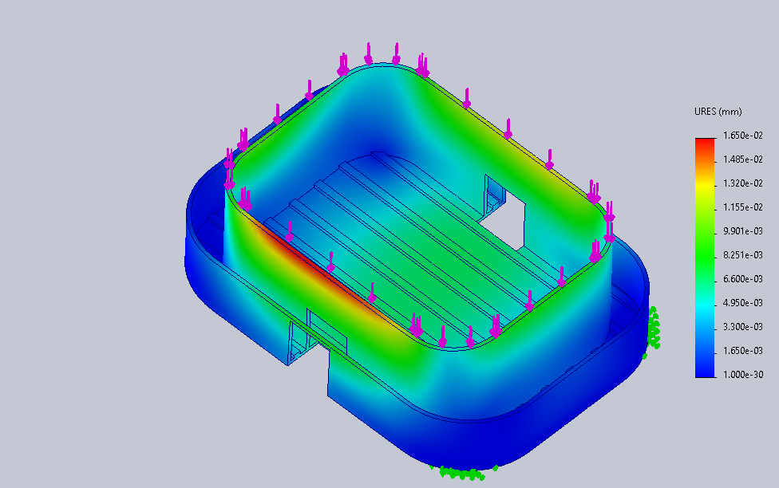
Fig. 1 - Static structural analysis

FEA in solidworks
Finite Element Analysis (FEA) in SOLIDWORKS is used to check how a component or assembly behaves when different loads and boundary conditions are applied. Since the model is already created in 3D, we can directly use it for simulation by defining the material, fixtures, loads, and mesh. In a simple FEA analysis, the model is divided into many small elements using a mesh. The software then calculates the response of each element and combines the results to show the overall behaviour of the component.Using FEA in SOLIDWORKS, we can study stress, strain, displacement, deformation, and factor of safety. The results can be viewed through colour contour plots and graphs, which make it easy to identify high-stress and high-deformation areas.
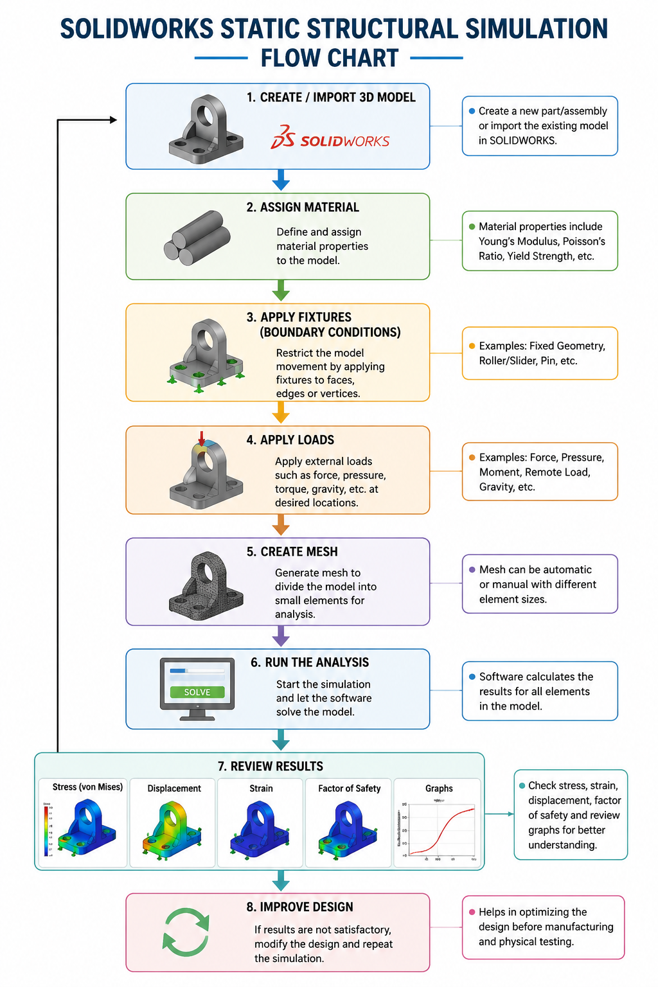
Fig. 2 - FEA in solidworks

Procedure
- Modelling of the structure to the required dimensions
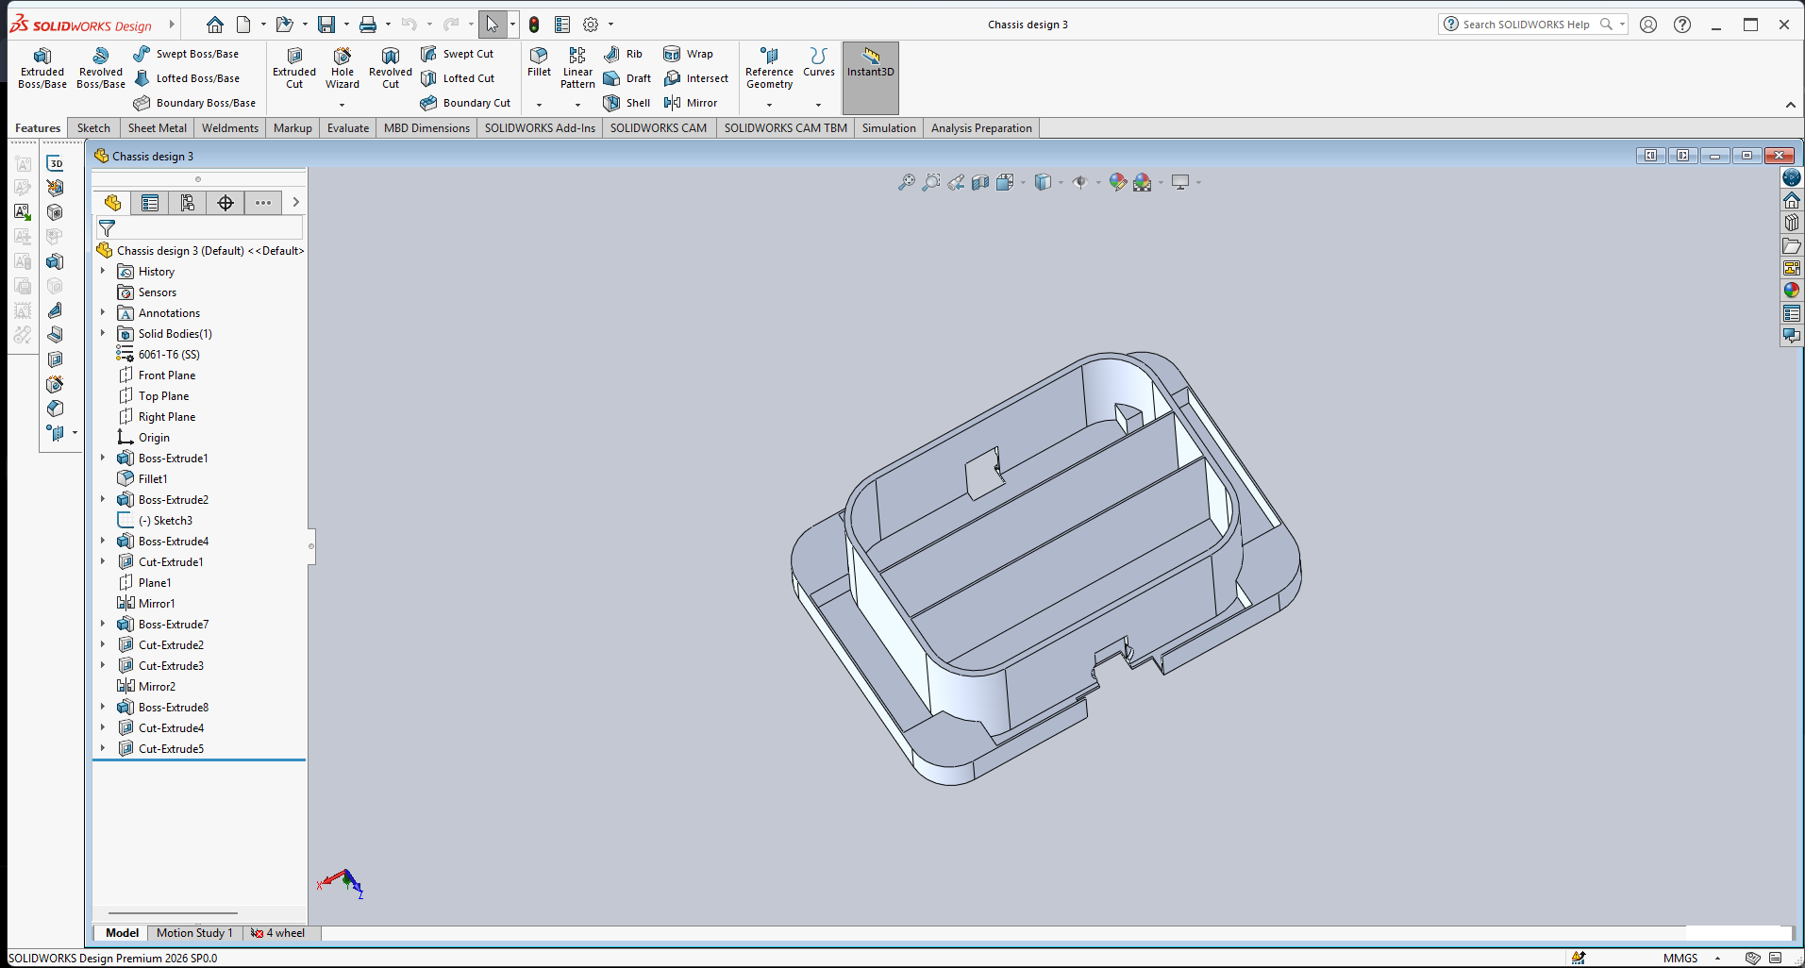

- In Solidworks add-in - Simulation (New study)
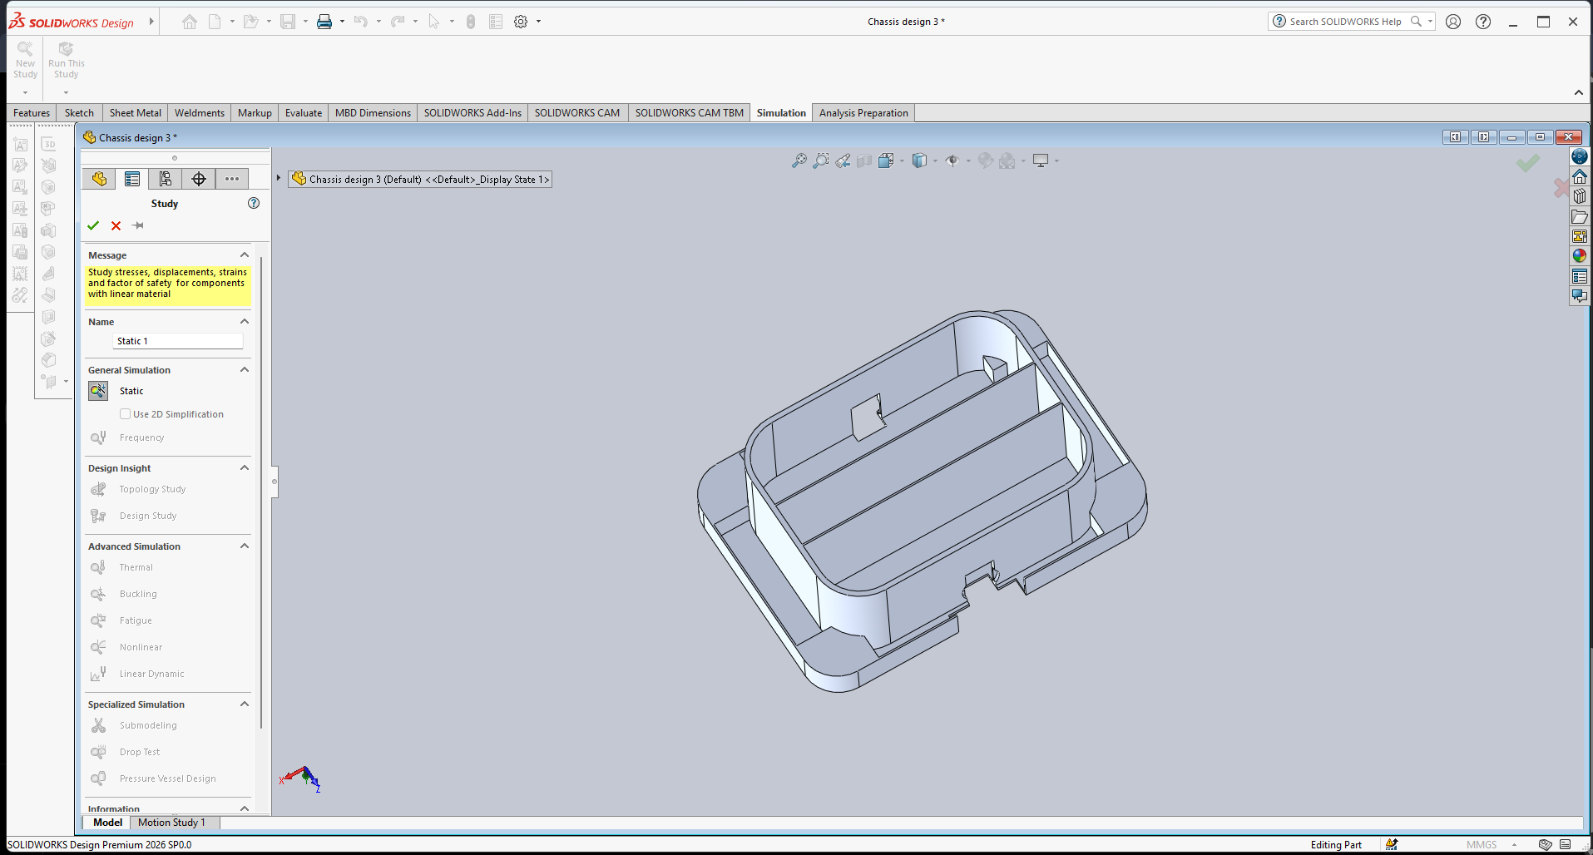

- Applying boundary conditions (Material selection)
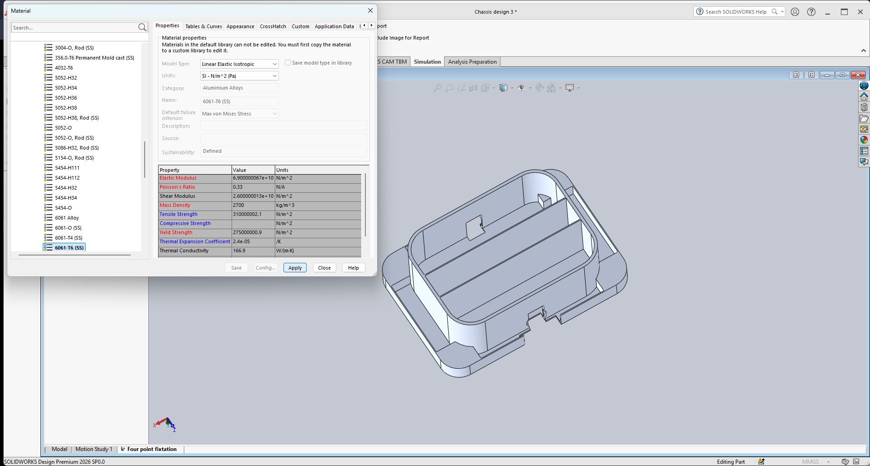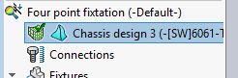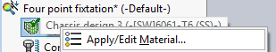

- Applying Fixed position

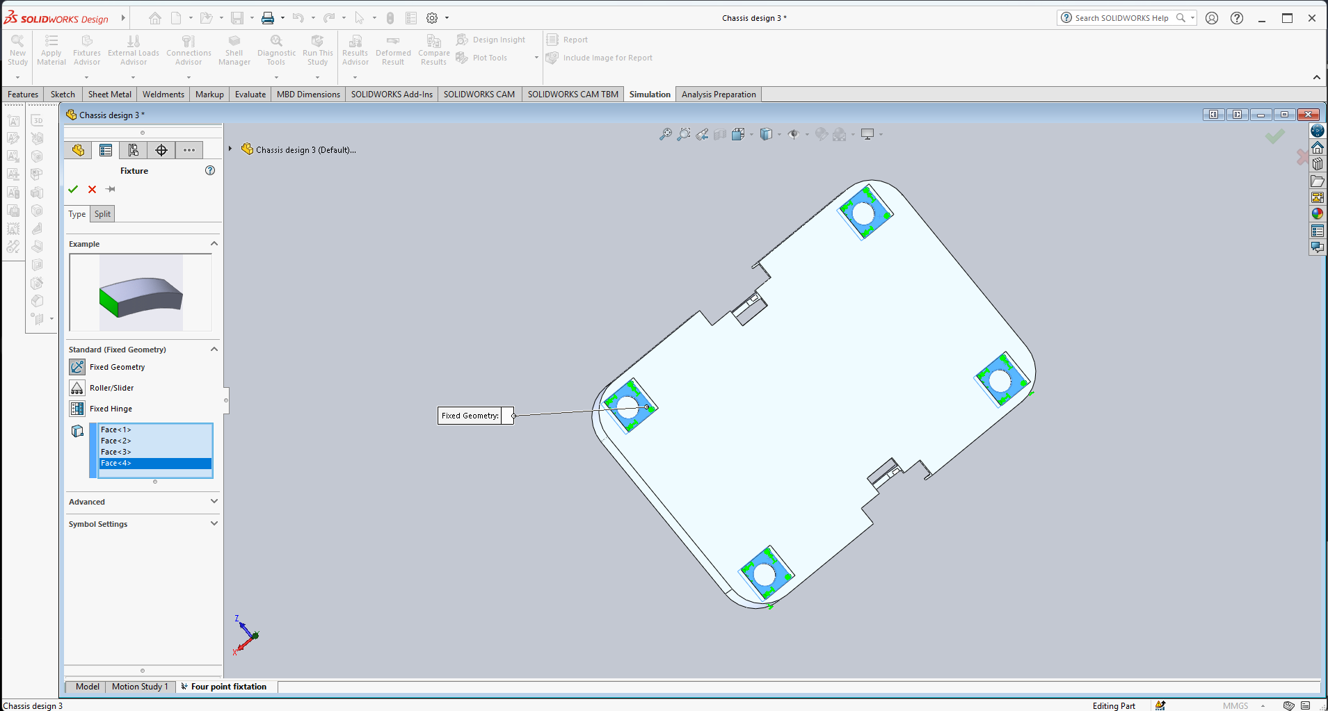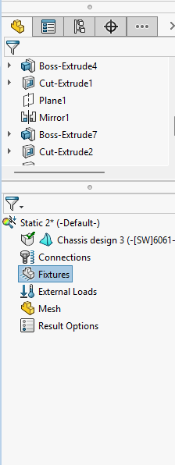
- Loading conditions
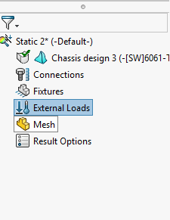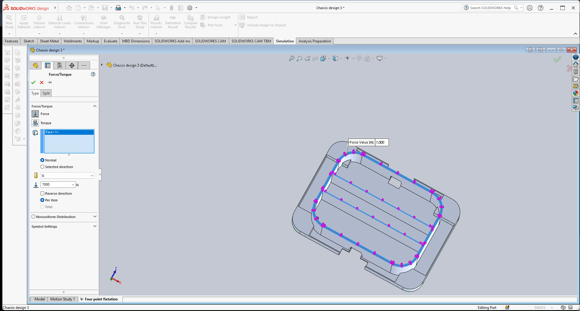
- Meshing
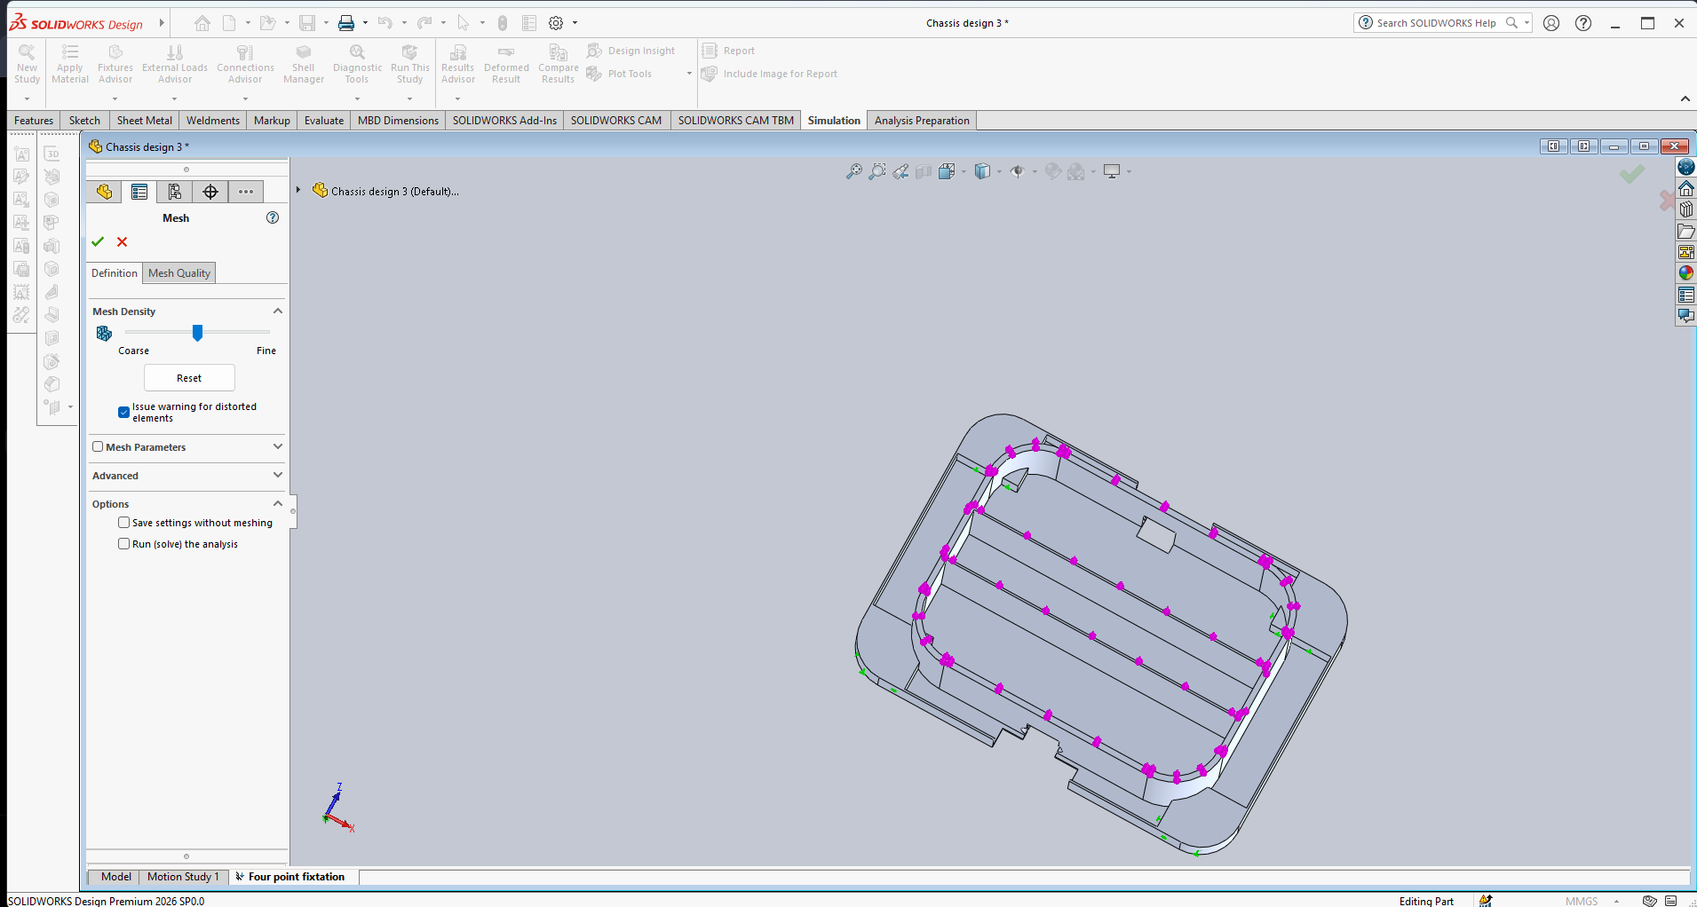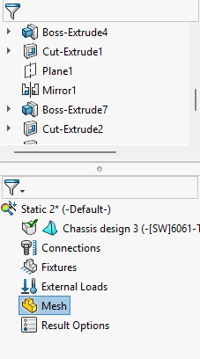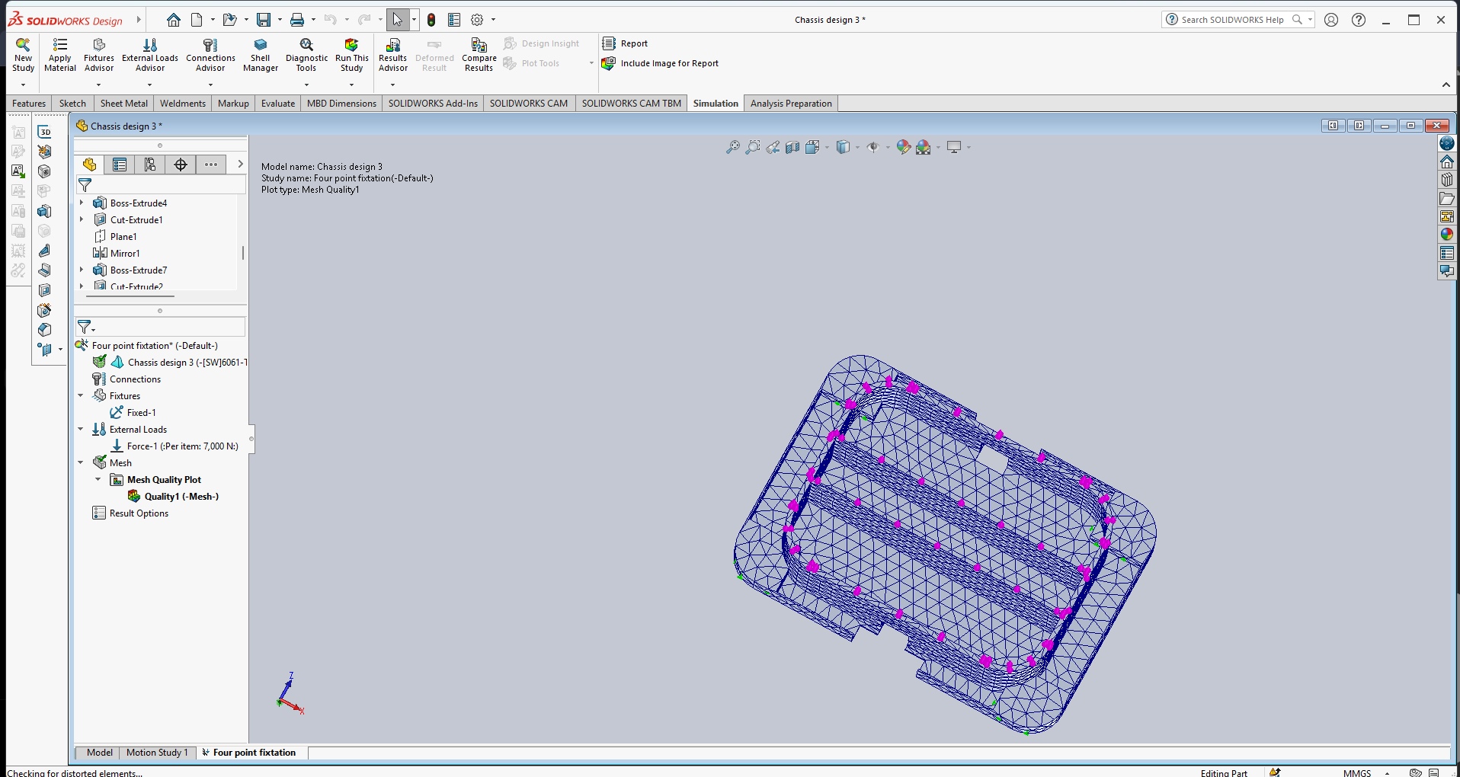
- Results
